PUNE INSTITUTE OF COMPUTER TECHNOLOGY

Department of Computer Engineering

DBMSL (310247)

K-1 Batch Roll no-31109

Name -Jayesh Gopal Bangad

A4 Assignment

1. 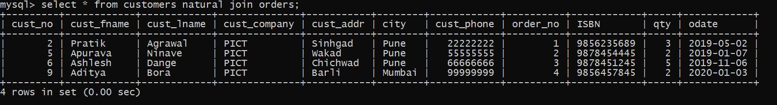Find Customer details and order details using NATURAL JOIN.
2. Find the book_ title, author_name, country.

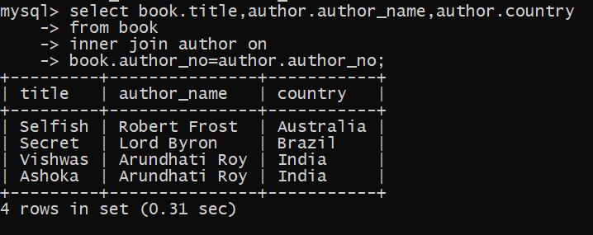

1. 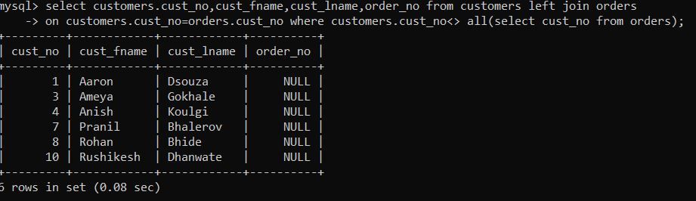Find the customer ID, name and order_no of customers who have never placed an order.

5.Display cust_fname, title,author_no,publisher_year where ISBN=1234.

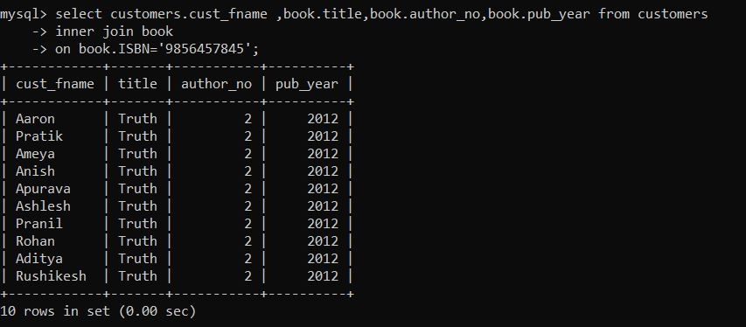

6. Display the total number of books and customer name.

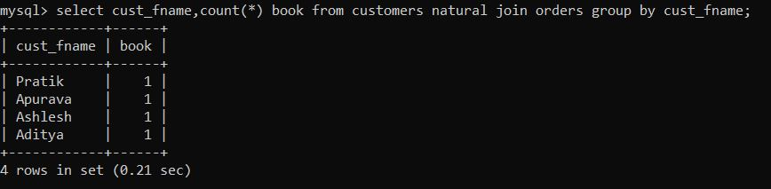

7. List the cust_id, order_no and ISBN with books having title 'mysql'.

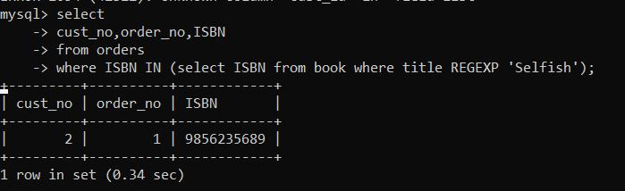

8. Find the names of all the companies that ordered books in the year 2015.

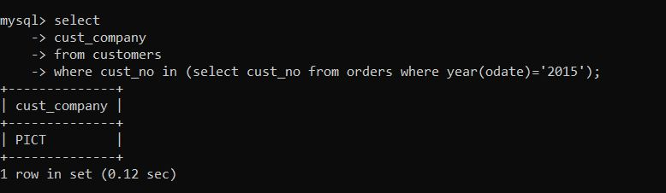

9. Create view showing the author and book details.

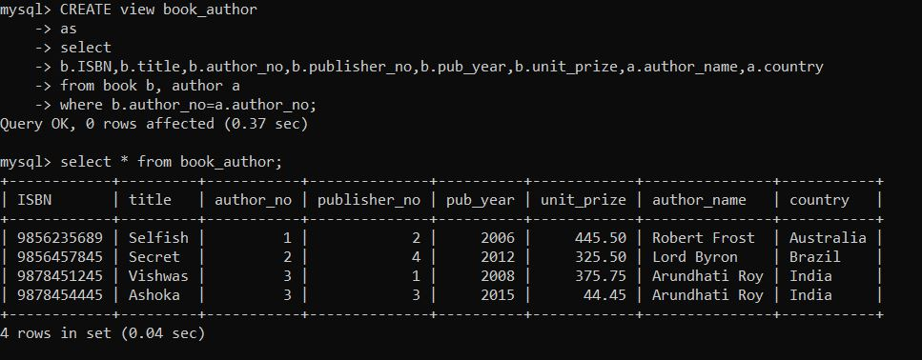

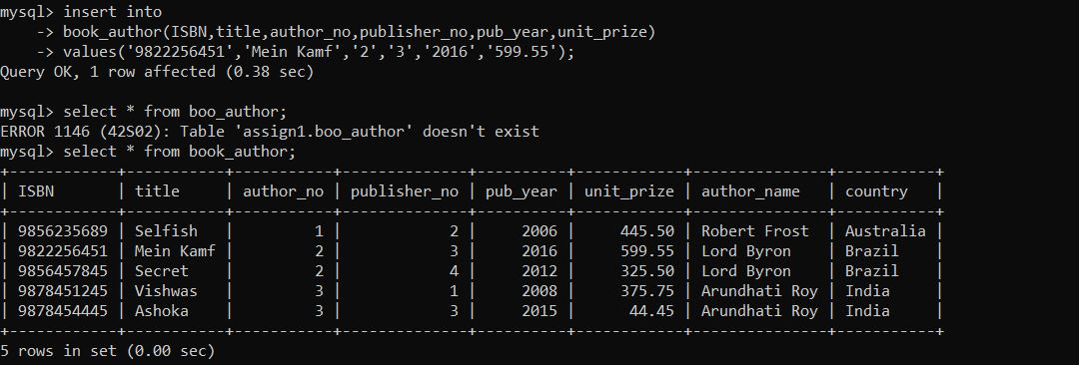10. Perform Manipulation on simple view-Insert, update, delete, drop view.

